LAB EXPERIMENT RECORD

SET 24: PRODUCT INVENTORY MANAGEMENT

Department | CSE – AI & DS
Course Code / Course Name | DSA0206 / Data Handling and Visualization
Experiment | Data Visualization using R
Name | M.Teja kumar
Register Number | 192424308
Date | 15 OCTOBER 2026
Day | Thursday

Aim
To analyze product inventory by visualizing available quantities, examining the relationship between product price and quantity available, and comparing inventory quantities across product categories.

Dataset: Product Inventory
Product_Name | Price | Quantity_Available | Category
Product A | 20 | 250 | Electronics
Product B | 15 | 175 | Furniture
Product C | 18 | 300 | Electronics
Product D | 22 | 200 | Furniture
Product E | 25 | 220 | Electronics
Note: The table above is reconstructed from the values shown in the supplied RStudio screenshots. The screenshots show five products with quantities 250, 175, 300, 200, and 220 and prices 20, 15, 18, 22, and 25. Categories are represented as Electronics and Furniture in the stacked bar chart.

PROGRAM 1: Scatter Plot of Product Price vs Quantity Available
Objective: To examine whether product price is associated with the quantity available in inventory.
# SET 24: Product Inventory Management data <- data.frame(
Product_Name = c("Product A", "Product B", "Product C",
"Product D", "Product E"), Price = c(20, 15, 18, 22, 25),
Quantity_Available = c(250, 175, 300, 200, 220)
)

# Scatter plot plot(
data$Price, data$Quantity_Available, pch = 19, col = "blue",
main = "Product Price vs Quantity Available", xlab = "Product Price",
ylab = "Quantity Available"
)

# Add product labels text(
data$Price, data$Quantity_Available,
labels = data$Product_Name, pos = 3, cex = 0.8
)

# Add trend line

model <- lm(Quantity_Available ~ Price, data = data) abline(model, col = "red", lwd = 2)

# Calculate correlation
correlation <- cor(data$Price, data$Quantity_Available) cat("Correlation coefficient:", round(correlation, 3), "\n")

Procedure: Plot Price on the X-axis and Quantity_Available on the Y-axis. Product labels identify each point, the red line represents a fitted linear trend, and cor() calculates the Pearson correlation.
Observation / Result: The screenshot reports a correlation of approximately -0.048, indicating almost no linear relationship between price and quantity in this five-product sample. The sample is small, so this should not be generalized beyond the displayed products.
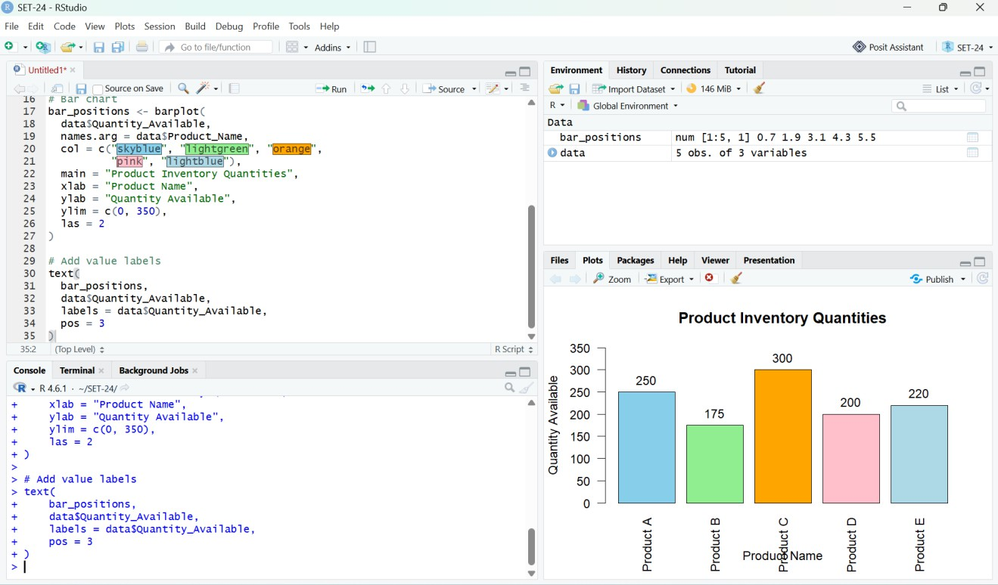
Figure 1. RStudio output: product price versus quantity available, with a fitted trend line.

PROGRAM 2: Bar Chart of Product Inventory Quantities
Objective: To compare the available stock quantities of the five products.
# Bar chart of available quantities bar_positions <- barplot(
data$Quantity_Available, names.arg = data$Product_Name,
col = c("skyblue", "lightgreen", "orange", "pink", "lightblue"), main = "Product Inventory Quantities",
xlab = "Product Name",
ylab = "Quantity Available", ylim = c(0, 350),
las = 2
)

# Add quantity labels text(
bar_positions, data$Quantity_Available, labels = data$Quantity_Available,

pos = 3
)

Procedure: barplot() displays one bar for each product, and text() adds the exact stock quantity above each bar.
Observation / Result: Product C has the highest quantity available at 300 units. Product B has the lowest quantity at 175 units. Products A, D, and E have 250, 200, and 220 units, respectively.
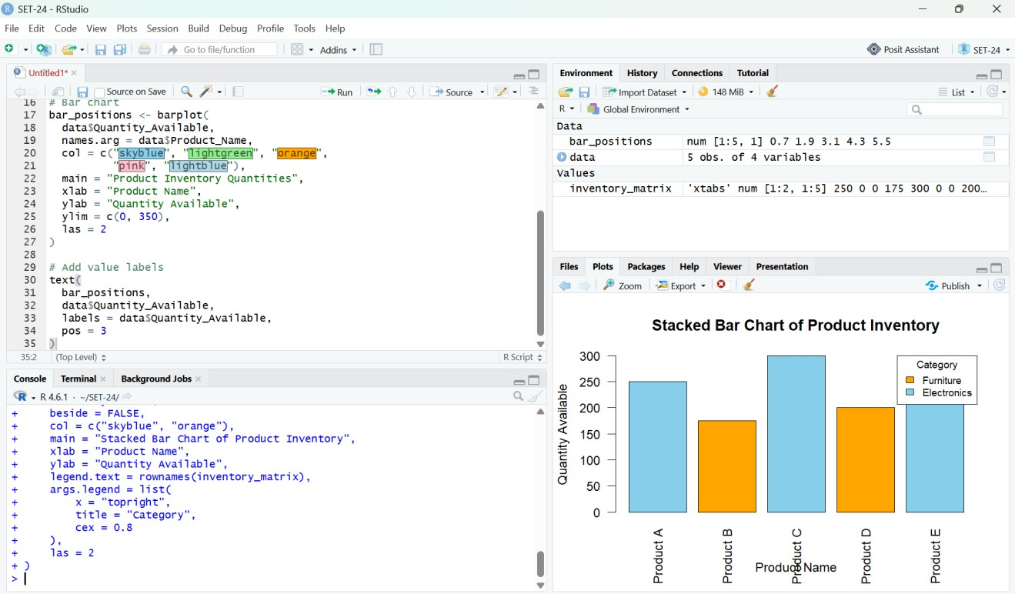
Figure 2. RStudio output: product inventory quantities.

PROGRAM 3: Stacked Bar Chart of Product Inventory by Category
Objective: To compare product quantities across categories using a stacked bar chart. The category split follows the illustrative grouping shown in the supplied screenshot.
# Add product categories data$Category <- c(
"Electronics", "Furniture", "Electronics", "Furniture", "Electronics"
)

# Create category-by-product matrix inventory_matrix <- xtabs(
Quantity_Available ~ Category + Product_Name, data = data
)

# Stacked bar chart barplot(
inventory_matrix, beside = FALSE,
col = c("orange", "skyblue"),
main = "Stacked Bar Chart of Product Inventory", xlab = "Product Name",
ylab = "Quantity Available",
legend.text = rownames(inventory_matrix),

args.legend = list( x = "topright", title = "Category", cex = 0.8
),
las = 2
)

Procedure: xtabs() constructs a category-by-product table. barplot() displays the quantities by product and uses different colors to distinguish categories.
Observation / Result: The chart differentiates Electronics and Furniture inventory. Product A, C, and E are shown as Electronics; Product B and D are shown as Furniture. Since each product is assigned to one category, each bar contains a single non-zero category segment.
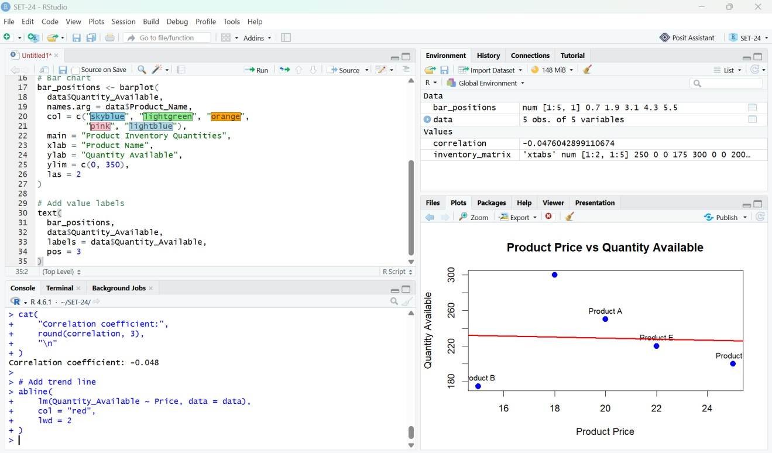
Figure 3. RStudio output: stacked bar chart of product inventory by category.

PROGRAM 4: Exporting Inventory Data for a Dashboard
Objective: To export the inventory dataset so it can be used in Tableau for an interactive inventory dashboard.
# Export inventory data for Tableau
write.csv(data, "SET24_Product_Inventory.csv", row.names = FALSE)

# Display the current working directory getwd()

Tableau Dashboard Procedure
- Run the export code in RStudio and note the folder returned by getwd().
- Open Tableau Desktop or Tableau Public and connect to SET24_Product_Inventory.csv.
- Create a bar-chart worksheet using Product_Name and Quantity_Available.
- Create a scatter-plot worksheet using Price and Quantity_Available; add Product_Name to Detail or Label.
- Use Category as Color in a category comparison worksheet, then place the worksheets on a dashboard.

- Add filters for Product_Name and Category if useful, and check tooltips and chart titles before saving.

Overall Result
The product inventory was analyzed using a price-versus-quantity scatter plot, a bar chart of available quantities, and a stacked bar chart by category. Product C has the largest stock (300 units), Product B has the smallest stock (175 units), and the displayed price–quantity correlation is approximately -0.048.

Conclusion
R visualizations help compare inventory levels and inspect possible relationships between product price and stock. In the supplied sample, there is almost no linear association between price and available quantity. The category chart and exported CSV can be used as the basis for an interactive Tableau dashboard.

